The maximum weight allowed for a tandem axle on interstate highway is 36,000 pounds.

The maximum weight allowed for a tandem axle on non-interstate highway is 40,000 pounds.

A tandem axle is defined as two or more consecutive axles, the centers of which may be included between parallel vertical planes spaced more than forty inches and not more than ninety-six inches apart, extending
across the full width of the vehicle.
C.R.S. 42-4-507(2)(c), C.R.S. 42-4-507(4)(b).

The maximum weight allowed for a single axle on any highway is 20,000 pounds.

A single axle is defined as all wheels, whose centers may be included within two parallel transverse vertical planes not more than forty inches apart, extending across the full width of the vehicle.
C.R.S. 42-4-507(2)(b), C.R.S. 42-4-507(4)(a).

Colorado Axle Weight Limits
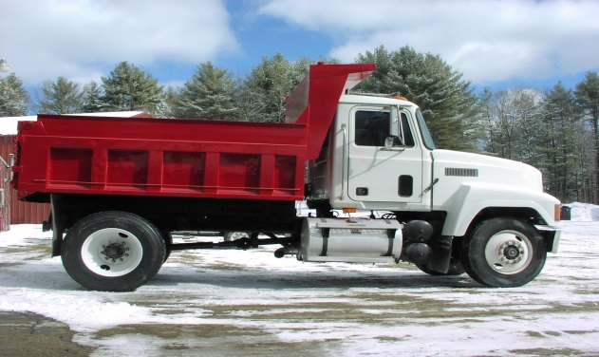

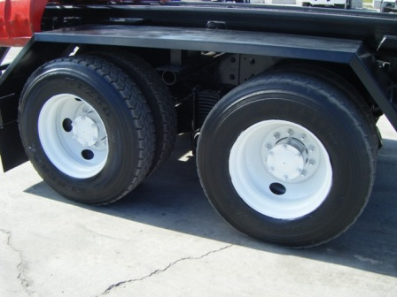
EXCEPTIONS

• The single axle weight limit is 21,000 pounds for a digger derrick or bucket boom truck operated by an
electric utility on a non-interstate highway. C.R.S. 42-4-507(2)(b.5)

• The gross weight limit for a vehicle utilizing “alternative fuel” as defined in C.R.S. 25-7-106.8(1)(a), and
operating on a non-interstate highway is increased by 1,000 pounds. C.R.S. 42-4-508(1.5)

• Any vehicle that utilizes an auxiliary power or idle reduction technology unit in order to promote reduction of
fuel use and emissions because of engine idling, shall have the actual weight of the auxiliary power or idle
reduction technology unit, up to 550 lbs., exempted from the calculation of actual axle and gross vehicle
weight. To be eligible for this exemption, the operator of the vehicle must be able to prove:
(i) By written certification, the actual weight of the APU; and
(ii) By demonstration or certification, that the idle reduction technology is fully functional at all times.
Certification of the weight of the APU must be available to law enforcement officers if the vehicle is
found in violation of applicable weight laws. The additional weight allowed cannot exceed 400 lbs. or the
weight certified whichever is less.

