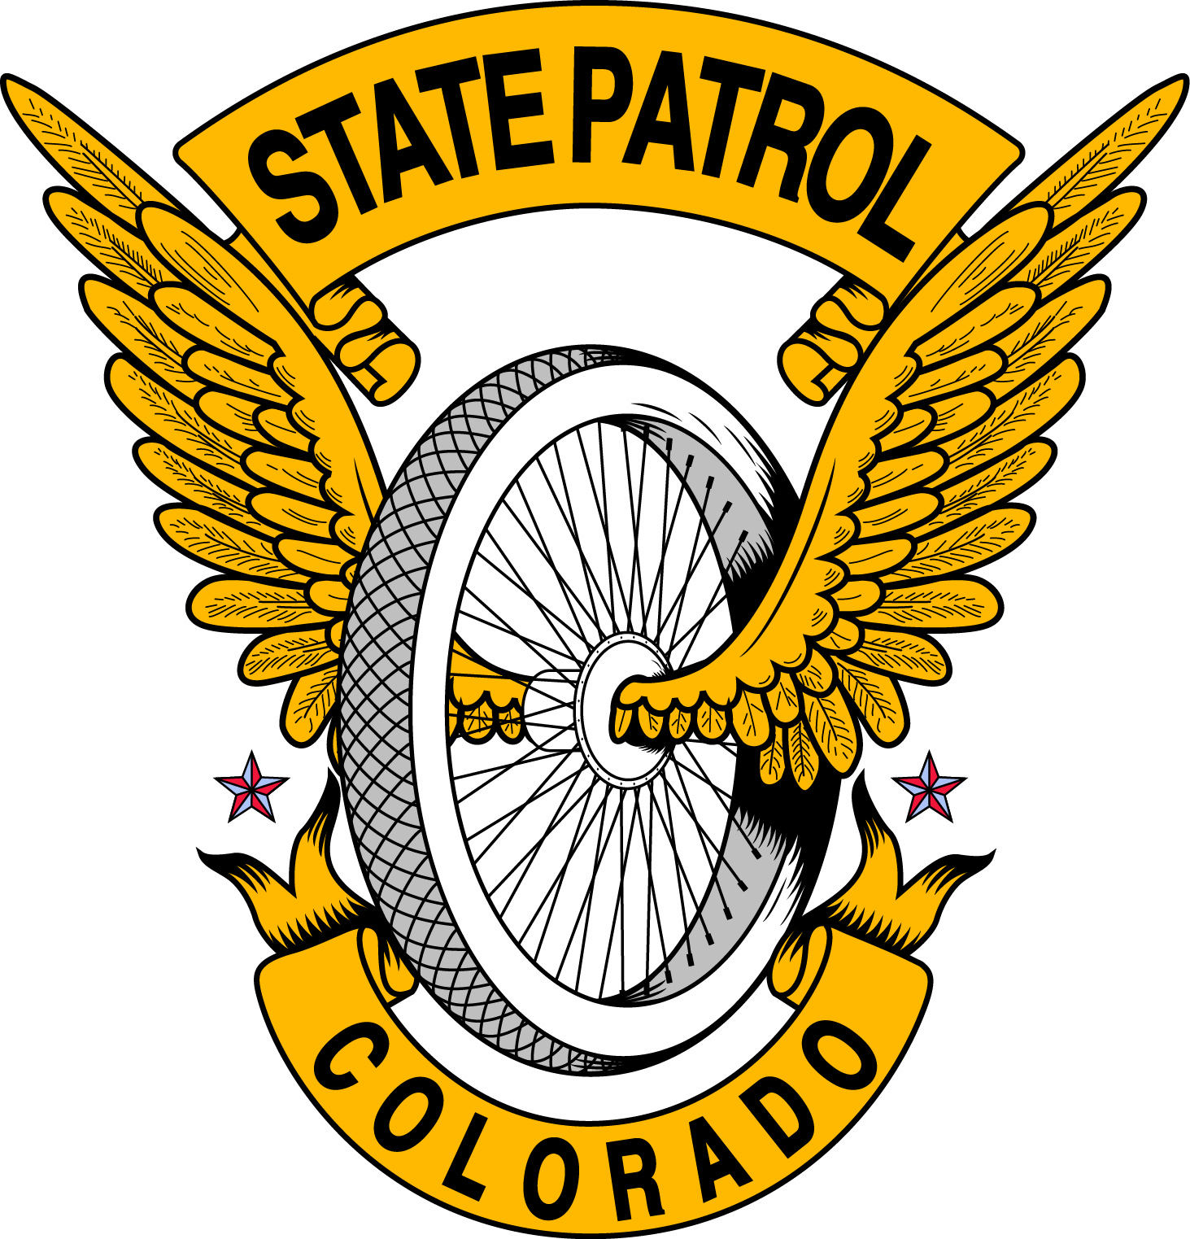
Colorado State Patrol
Complaint Form

Complainant’s Name: |  | Address:
Telephone Number: | Email Address: | City, State: | Zip Code:

The Colorado State Patrol will impartially investigate complaints involving its employees. To expedite this process and gather the facts involved as accurately as possible, you are asked to provide a written statement regarding your complaint. In the space below, specifically identify the basis for your complaint and provide as much detail as possible concerning the incident. Keep a copy for your records and send another copy to the Colorado State Patrol within 10 days. Upon receipt of your statement, the State Patrol acknowledges it will investigate the complaint to the fullest extent possible and inform you of the results within 60 days. Failure to complete and return this form as prescribed may result in dismissal of your complaint.
Any questions you may have in the interim should be directed to the following person:
at
Patrol Supervisor Telephone Number

Date and Time of Incident:

DETAILS OF THE COMPLAINT: (Please print legibly or type. Use additional sheets if necessary)

I hereby certify that the statements given by me herein are true and accurate to the best of my knowledge. Further, I understand that making false statements may constitute a violation of law.

Signature of Complainant Date

Internal use only  Date and Time Complaint was Received: | Complaint Case Number:

